DISSENTER (OLD DISSENTING MEETING HOUSE / UNITARIAN CHAPEL)

Storytelling and acoustic evening concerts and events are held in the chapel, and Children’s Festival events are held in the Dance Studio.

Address: All Saints Road, Sidmouth, EX10 8ER. Located on the corner of the High Street and All Saints Road
What3words location: ///desk.prop.petty
Parking: No parking. Nearest car parks are Rugby Club and Roxburgh.
Facilities: Toilets
Access: There is a step down through the door to the chapel, and narrow doorways.
Chapel
Dance Studio
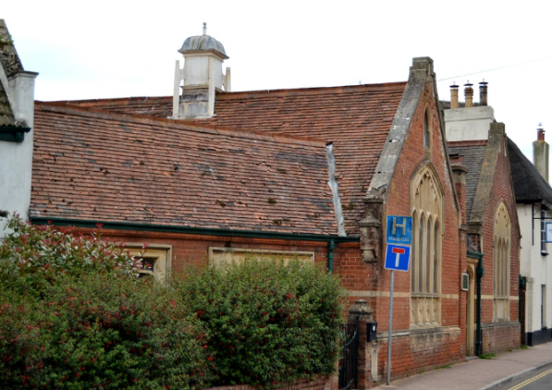
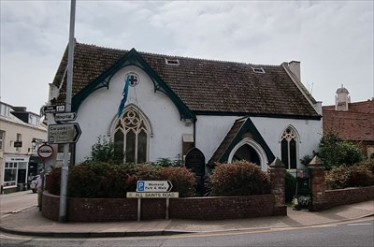
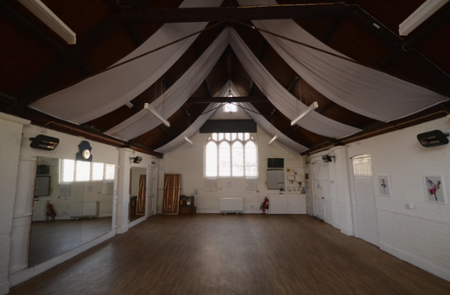
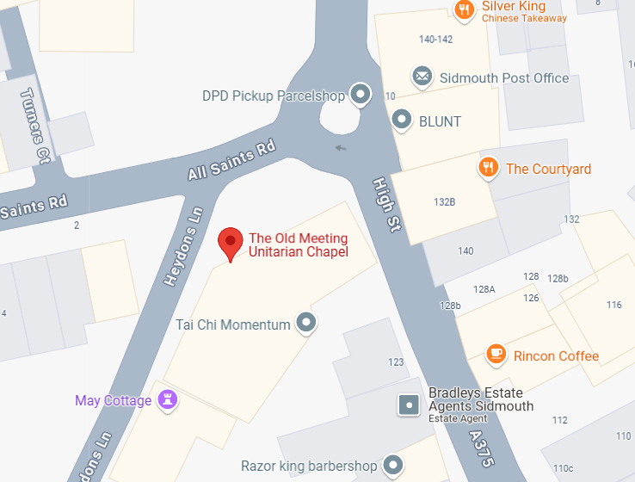
Chapel entrance
Dance Studio entrance

