**MANOR PAVILION & ARTS CENTRE**

This venue includes the following spaces:

* MANOR PAVILION THEATRE
* MANOR PAVILION BAR
* ARTS CENTRE (adjoining The Manor Pavilion)

**In the heart of town, the Manor Pavilion is a charming theatre with comfy raked seating. The theatre is host to a programme of shows, concerts and workshops. The bar will hold Storytelling events. Adjoining the theatre is the Arts Centre, where talks, concerts and workshops are held in a ground-floor room.**

**Address**:   Manor Road, EX10 8RP

**What3words**:

Entrance to Manor Pavilion: ///edits.petal.catch.

Entrance to Arts Centre: ///feeds.supper.still

**Nearest car parks**: Manor Pavilion Car park, Bedford Lawn Car Park , Rugby Club, Cricket Club.

**Facilities**: Bar during evening events, toilets including disabled toilets in the theatre.

**Access - Manor Pavilion Theatre & Bar:** Level access at entrance, spaces in the theatre for wheelchairs. The Manor Pavilion is on an inclined road. Wheelchair seats are located on ground level and there is step-free access. There are some steps on the way to the bar, however there is a stairlift (see image). The theatre has a loop aid hearing system that audio to visitor's hearing aids.

**Access - The Arts Centre**: At the Corner of Station Road and Manor Road. Flat access from side path or two steps and sloped front path (from Station Road side). Side path is on an inclined road.

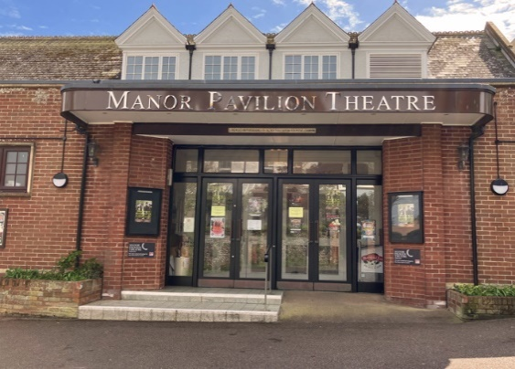

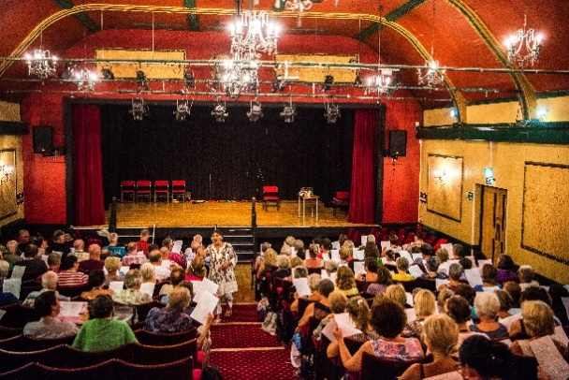

Stairs & Stairlift from foyer to Bar

Bar

The Arts Centre

Entrance

**Arts Centre**

Entrance either from Station Road (B3176) or side path from Manor Road.

**Manor Pavilion**

Entrance on Manor Road