RUGBY CLUB
First-floor room is used for a variety of workshops and sessions.

Address: Heydons Lane, EX10 8NJ
What3words: ///riots.cool.then
Nearest car park: Rugby Club car park.
Facilities: Toilets including accessible toilets.
Access: Level access. The entrance is about halfway along the building. Access to first floor via stairs which have a stair lift.

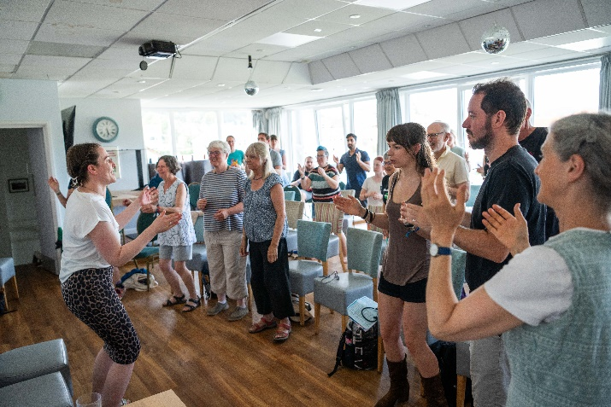
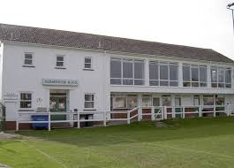

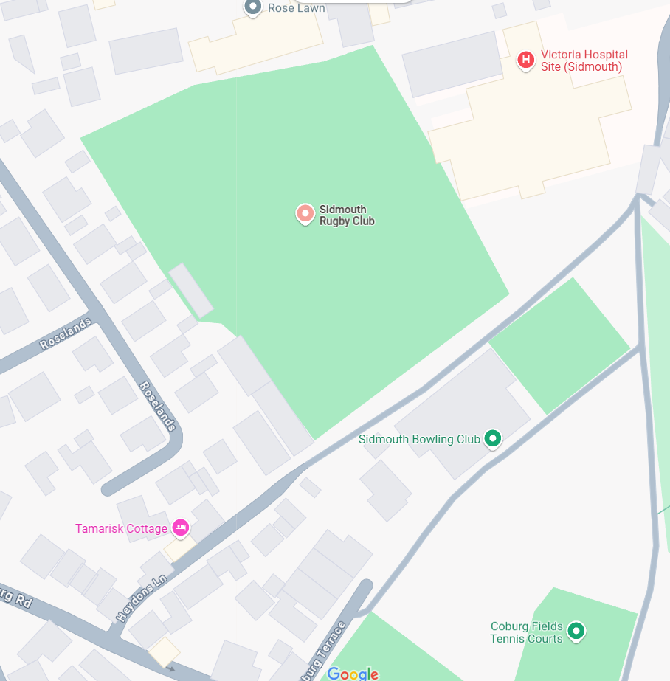

Rugby Club
Entrance

