**SIDMOUTH PRIMARY SCHOOL** (Vicarage Road site)

**Dance, Music and Instrumental workshops take place here *in the classroom, Hall & Library.***

**Address**: Sidmouth C of E Primary School, Vicarage Road, EX10 8UG

**What3words**: ///insect.when.funded

**Nearest car park**: Disabled parking available. Nearest car parks are Roxburgh, and Rugby Club.

**Facilities**: Toilets including accessible toilets.

**Access**: Enter the venue via the playground at the back. Level access. Access to the school is via a very inclined driveway so may not be suitable for some patrons.

Entrance to the School via driveway off Vicarage Road

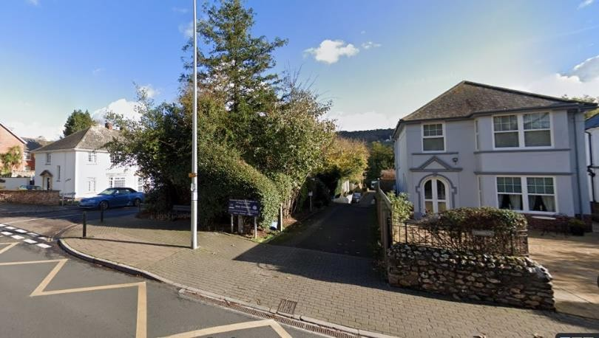

**Walking route to the venue**

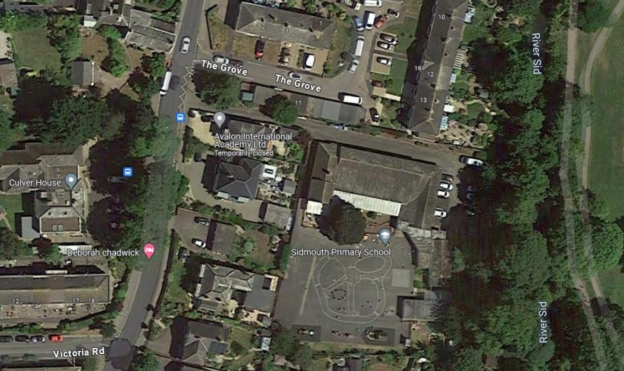

Venue entrance here, enter via the playground

Disabled parking only