STOWFORD RISE COMMUNITY CENTRE
Evening folk dances take place at this modern community centre to the north of town.
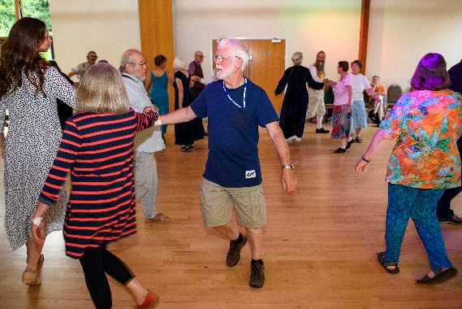
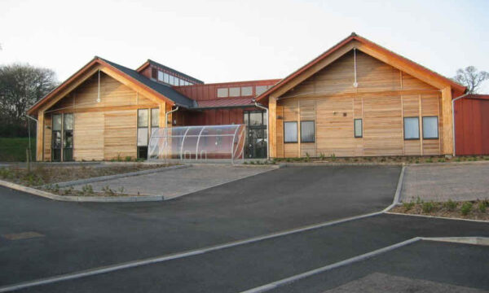

Address: Stowford Rise Community Centre, Chambers Close, Sidmouth, EX10 9YL.
The centre is opposite Waitrose, to the north of Sidmouth town.
What3words location: //forms.rushed.thing
Parking: Plenty of parking
Facilities: Toilets including accessible toilets.
Access: The building is fully accessible.
