Sidmouth Horse Trials - Entry Form 2026
Name of Hobby Horse/Beast of Disguise:

Type of Horse/Beast:

Stable:

Owner/trainer:

Pedigree/lineage:

Past form:

Special skill:

Ambitions for the year should you win the Sidmouth Hobby Horse of the Year title:

Contact name :  Contact email : | Contact phone :  Contact physical address :

Print and bring this form with you to the Horse Trials
Email to Stephen Rowley to confirm your attendance steve@artension.com
Contact on the day : 07803052723

Sidmouth Horse Trials 2026
The Hobby Horse of the Year Show
Sunday 2nd August from 1pm
Connaught Gardens
Inviting all Hobby Horses, Beasts of Disguise, Folk Animals, Dragons
To perform before a Distinguished Panel of Judges
A competition for the The Aardman Trophy
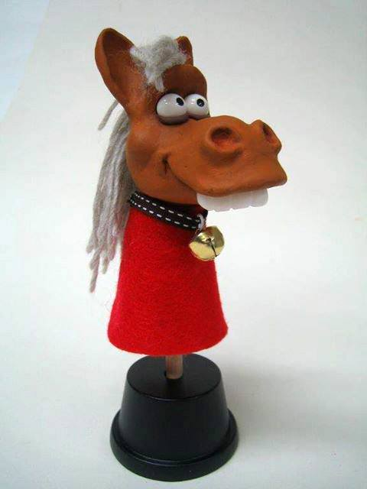
To be presented by Peter Lord founder of Aardman and creator of Morph
All entrants must complete an Entry Form to take part.
12.30onwards Beast/Hobby Horse Registration – Connaught Gardens
1.00 UkeStroud Horse Trials Overture
1.30 The Hobby Horse of the Year Show – Parade of the Animals
2.45 Prizegiving

Ringmasters: Stephen Rowley/Alex Merry
Head Judge: Janet Dowling
Contact: 07803052723 steve@artension.com
www.sidmouthhorsetrials.org.uk

